NAME – KARANDEEP SINGH ATER
CLASS- CSE-1
ROLL NO. 05813202717
PAPER CODE- ETIT-452

Aim- Design a program on ‘Social Networks combating COVID-19’
Theory-
We address the diffusion of information about the COVID-19 with a massive data analysis on Twitter, Instagram, YouTube, Reddit and Gab. We analyze engagement and interest in the COVID-19 topic and provide a differential assessment on the evolution of the discourse on a global scale for each platform and their users. We fit information spreading with epidemic models characterizing the basic reproduction number R0R0 for each social media platform. Moreover, we identify information spreading from questionable sources, finding different volumes of misinformation in each platform. However, information from both reliable and questionable sources do not present different spreading patterns. Finally, we provide platform-dependent numerical estimates of rumors’ amplification.

The World Health Organization (WHO) defined the SARS-CoV-2 virus outbreak as a severe global threat1. As foreseen in 2017 by the global risk report of the World Economic forum, global risks are interconnected. In particular, the case of the COVID-19 epidemic (the infectious disease caused by the most recently discovered human coronavirus) is showing the critical role of information diffusion in a disintermediated news cycle2.
The term infodemic3,4 has been coined to outline the perils of misinformation phenomena during the management of disease outbreaks5,6,7, since it could even speed up the epidemic process by influencing and fragmenting social response8. As an example, CNN has recently anticipated a rumor about the possible lock-down of Lombardy (a region in northern Italy) to prevent pandemics9, publishing the news hours before the official communication from the Italian Prime Minister. As a result, people overcrowded trains and airports to escape from Lombardy toward the southern regions before the lock-down was put in place, disrupting the government initiative aimed to contain the epidemics and potentially increasing contagion. Thus, an important research challenge is to determine how people seek or avoid information and how those decisions affect their behavior10, particularly when the news cycle—dominated by the disintermediated diffusion of information—alters the way information is consumed and reported on.
The case of the COVID-19 epidemic shows the critical impact of this new information environment. The information spreading can strongly influence people’s behavior and alter the effectiveness of the countermeasures deployed by governments. To this respect, models to forecast virus spreading are starting to account for the behavioral response of the population with respect to public health interventions and the communication dynamics behind content consumption8,11,12.
Social media platforms such as YouTube and Twitter provide direct access to an unprecedented amount of content and may amplify rumors and questionable information. Taking into account users’ preferences and attitudes, algorithms mediate and facilitate content promotion and thus information spreading13. This shift from the traditional news paradigm profoundly impacts the construction of social perceptions14 and the framing of narratives; it influences policy-making, political communication, as well as the evolution of public debate15,16, especially when issues are controversial17. Users online tend to acquire information adhering to their worldviews18,19, to ignore dissenting information20,21 and to form polarized groups around shared narratives22,23. Furthermore, when polarization is high, misinformation might easily proliferate24,25. Some studies pointed out that fake news and inaccurate information may spread faster and wider than fact-based news26. However, this might be platform-specific effect. The definition of “Fake News” may indeed be inadequate since political debate often resorts to labelling opposite news as unreliable or fake27. Studying the effect of the social media environment on the perception of polarizing topics is being addressed also in the case of COVID-19. The issues related to the current infodemics are indeed being tackled by the scientific literature from multiple perspectives including the dynamics of hatespeech and conspiracy theories28,29, the effect of bots and automated accounts30, and the threats of misinformation in terms of diffusion and opinions formation31,32.
In this work we provide an in-depth analysis of the social dynamics in a time window where narratives and moods in social media related to the COVID-19 have emerged and spread. While most of the studies on misinformation diffusion focus on a single platform17,26,33, the dynamics behind information consumption might be particular to the environment in which they spread on. Consequently, in this paper we perform a comparative analysis on five social media platforms (Twitter, Instagram, YouTube, Reddit and Gab) during the COVID-19 outbreak. The dataset includes more than 8 million comments and posts over a time span of 45 days. We analyze user engagement and interest about the COVID-19 topic, providing an assessment of the discourse evolution over time on a global scale for each platform. Furthermore, we model the spread of information with epidemic models, characterizing for each platform its basic reproduction number (R0R0), i.e. the average number of secondary cases (users that start posting about COVID-19) an “infectious” individual (an individual already posting on COVID-19) will create. In epidemiology, R0R0 = 1 is a threshold parameter. When R0<1R0<1 the disease will die out in a finite period of time, while the disease will spread for R0>1R0>1. In social media, R0>1R0>1 will indicate the possibility of an infodemic.
Finally, coherently with the classification provided by the fact-checking organization Media Bias/Fact Check34 that classifies news sources based on the truthfulness and bias of the information published, we split news outlets into two groups. These groups are either associated to the diffusion of (mostly) reliable or (mostly) questionable contents and we characterize the spreading of information regarding COVID-19 relying on this classification. We find that users in mainstream platforms are less susceptible to the diffusion of information from questionable sources and that information deriving from news outlets marked either as reliable or questionable do not present significant difference in the way it spreads.
Our findings suggest that the interaction patterns of each social media combined with the peculiarity of the audience of each platform play a pivotal role in information and misinformation spreading. We conclude the paper by measuring rumor’s amplification parameters for COVID-19 on each social media platform.
Diagram:
1.
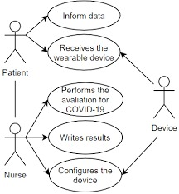

2.
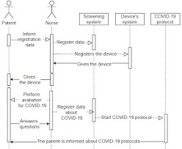

3.
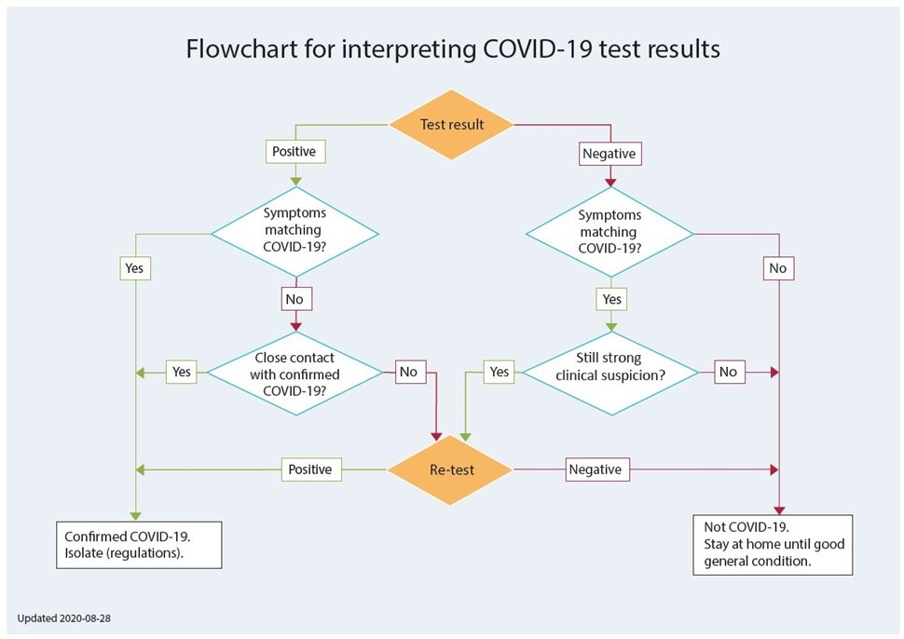
Code-
<?xml version="1.0" encoding="utf-8"?>
<resources>
<color name="colorPrimary">#42C14B</color>
<color name="colorPrimaryDark">#3BC545</color>
<color name="colorAccent">#05af9b</color>

<color name="color_one">#fb7268</color>
<color name="color_white">#ededf2</color>
</resources>
/ Volley library
implementation 'com.android.volley:volley:1.1.1'
<!--Allow Internet Permission-->
<uses-permission android:name="android.permission.INTERNET" />
maincovid.xml
<?xml version="1.0" encoding="utf-8"?>
<ScrollView
xmlns:android="http://schemas.android.com/apk/res/android"
xmlns:app="http://schemas.android.com/apk/res-auto"
xmlns:tools="http://schemas.android.com/tools"
android:layout_width="match_parent"
android:layout_height="match_parent"
android:background="@color/color_white"
android:orientation="vertical"
tools:context=".MainActivity">

<!--Linear Layout to display all the details-->
<LinearLayout
android:layout_width="match_parent"
android:layout_height="wrap_content"
android:padding="20dp"
android:orientation="vertical">

<!--Text view to display Global stats-->
<TextView
android:layout_width="match_parent"
android:layout_height="wrap_content"
android:text="Global Stats"
android:textColor="#050505"
android:textAllCaps="true"
android:textAlignment="center"
android:textSize="35sp"
android:textStyle="bold"/>

<!--Text view to display Total Cases-->
<TextView
android:layout_width="match_parent"
android:layout_height="wrap_content"
android:fontFamily="sans-serif-light"
android:layout_marginTop="20dp"
android:text="Total Cases"
android:textAlignment="center"
android:textStyle="bold"
android:textSize="30sp"/>

<!--Text view to display the updated number when data
will fetch from the API. For now default set to 0 -->
<TextView
android:layout_width="match_parent"
android:layout_height="wrap_content"
android:text="0"
android:id="@+id/tvCases"
android:textAlignment="center"
android:textSize="25sp"
android:textColor="@color/color_one"
android:textStyle="bold"
android:fontFamily="sans-serif-light" />

<!--Text view to display Recovered Cases-->
<TextView
android:layout_width="match_parent"
android:layout_height="wrap_content"
android:fontFamily="sans-serif-light"
android:text="Recovered"
android:textAlignment="center"
android:textStyle="bold"
android:textSize="30sp"/>

<!--Text view to display the updated number when data
will fetch from the API. For now default set to 0 -->
<TextView
android:layout_width="match_parent"
android:layout_height="wrap_content"
android:text="0"
android:id="@+id/tvRecovered"
android:textAlignment="center"
android:textSize="25sp"
android:textColor="@color/color_one"
android:textStyle="bold"
android:fontFamily="sans-serif-light" />

<!--Text view to display Critical Cases-->
<TextView
android:layout_width="match_parent"
android:layout_height="wrap_content"
android:fontFamily="sans-serif-light"
android:text="Critical"
android:textAlignment="center"
android:textStyle="bold"
android:textSize="30sp"/>

<!--Text view to display the updated number when data
will fetch from the API. For now default set to 0 -->
<TextView
android:layout_width="match_parent"
android:layout_height="wrap_content"
android:text="0"
android:id="@+id/tvCritical"
android:textAlignment="center"
android:textSize="25sp"
android:textColor="@color/color_one"
android:textStyle="bold"
android:fontFamily="sans-serif-light" />

<!--Text view to display Active Cases-->
<TextView
android:layout_width="match_parent"
android:layout_height="wrap_content"
android:fontFamily="sans-serif-light"
android:text="Active"
android:textAlignment="center"
android:textStyle="bold"
android:textSize="30sp"/>

<!--Text view to display the updated number when data
will fetch from the API. For now default set to 0 -->
<TextView
android:layout_width="match_parent"
android:layout_height="wrap_content"
android:text="0"
android:id="@+id/tvActive"
android:textAlignment="center"
android:textSize="25sp"
android:textColor="@color/color_one"
android:textStyle="bold"
android:fontFamily="sans-serif-light" />

<!--Text view to display Today Cases-->
<TextView
android:layout_width="match_parent"
android:layout_height="wrap_content"
android:fontFamily="sans-serif-light"
android:text="Today Cases"
android:textAlignment="center"
android:textStyle="bold"
android:textSize="30sp"/>

<!--Text view to display the updated number when data
will fetch from the API. For now default set to 0 -->
<TextView
android:layout_width="match_parent"
android:layout_height="wrap_content"
android:text="0"
android:id="@+id/tvTodayCases"
android:textAlignment="center"
android:textSize="25sp"
android:textColor="@color/color_one"
android:textStyle="bold"
android:fontFamily="sans-serif-light" />

<!--Text view to display Total Deaths-->
<TextView
android:layout_width="match_parent"
android:layout_height="wrap_content"
android:fontFamily="sans-serif-light"
android:text="Total Deaths"
android:textAlignment="center"
android:textStyle="bold"
android:textSize="30sp"/>

<!--Text view to display the updated number when data
will fetch from the API. For now default set to 0 -->
<TextView
android:layout_width="match_parent"
android:layout_height="wrap_content"
android:text="0"
android:id="@+id/tvTotalDeaths"
android:textAlignment="center"
android:textSize="25sp"
android:textColor="@color/color_one"
android:textStyle="bold"
android:fontFamily="sans-serif-light" />

<!--Text view to display Today Deaths-->
<TextView
android:layout_width="match_parent"
android:layout_height="wrap_content"
android:fontFamily="sans-serif-light"
android:text="Today Deaths"
android:textAlignment="center"
android:textStyle="bold"
android:textSize="30sp"/>

<!--Text view to display the updated number when data
will fetch from the API. For now default set to 0 -->
<TextView
android:layout_width="match_parent"
android:layout_height="wrap_content"
android:text="0"
android:id="@+id/tvTodayDeaths"
android:textAlignment="center"
android:textSize="25sp"
android:textColor="@color/color_one"
android:textStyle="bold"
android:fontFamily="sans-serif-light" />

<!--Text view to display Affected Countries-->
<TextView
android:layout_width="match_parent"
android:layout_height="wrap_content"
android:fontFamily="sans-serif-light"
android:text="Affected Countries"
android:textAlignment="center"
android:textStyle="bold"
android:textSize="30sp"/>

<!--Text view to display the updated number when data
will fetch from the API. For now default set to 0 -->
<TextView
android:layout_width="match_parent"
android:layout_height="wrap_content"
android:text="0"
android:id="@+id/tvAffectedCountries"
android:textAlignment="center"
android:textSize="25sp"
android:textColor="@color/color_one"
android:textStyle="bold"
android:fontFamily="sans-serif-light" />

</LinearLayout>

</ScrollView>
Java File
/ Create a String request using Volley Library

String url = "https:// corona.lmao.ninja/v2/all";

StringRequest request
= new StringRequest(
Request.Method.GET,
url,
new Response.Listener() {
@Override
public void onResponse(
String response)
{
}
},
new Response.ErrorListener() {
@Override
public void onErrorResponse(
VolleyError error)
{
}
});

RequestQueue requestQueue
= Volley.newRequestQueue(this);
requestQueue.add(request);
try {
// Creating object of JSONObject
JSONObject jsonObject
= new JSONObject(
response.toString());

// Set the data in text view
// which are available in JSON format
// Note that the parameter
// inside the getString() must match
// with the name given in JSON format
tvCases.setText(
jsonObject.getString("cases"));
tvRecovered.setText(
jsonObject.getString("recovered"));
tvCritical.setText(
jsonObject.getString("critical"));
tvActive.setText(
jsonObject.getString("active"));
tvTodayCases.setText(
jsonObject.getString("todayCases"));
tvTotalDeaths.setText(
jsonObject.getString("deaths"));
tvTodayDeaths.setText(
jsonObject.getString("todayDeaths"));
tvAffectedCountries.setText(
jsonObject.getString("affectedCountries"));
}
catch (JSONException e) {
e.printStackTrace();
Toast.makeText(MainActivity.this,
error.getMessage(),
Toast.LENGTH_SHORT)
.show();

Results
We analyze mainstream platforms such as Twitter, Instagram and YouTube as well as less regulated social media platforms such as Gab and Reddit. Gab is a crowdfunded social media whose structure and features are Twitter-inspired. It performs very little control on content posted; in the political spectrum, its user base is considered to be far-right. Reddit is an American social news aggregation, web content rating, and discussion website based on collective filtering of information.
We perform a comparative analysis of information spreading dynamics around the same argument in different environments having different interaction settings and audiences. We collect all pieces of content related to COVID-19 from the 1st of January to the 14th of February. Data have been collected filtering contents accordingly to a selected sample of Google Trends’ COVID-19 related queries such as: coronavirus, coronavirusoutbreak, imnotavirus, ncov, ncov-19, pandemic, wuhan. The deriving dataset is then composed of 1,342,103 posts and 7,465,721 comments produced by 3,734,815 users. For more details regarding the data collection refer to Methods.

Interaction patterns
First, we analyze the interactions (i.e., the engagement) that users have with COVID-19 topics on each platform. The upper panel of Fig. 1 shows users’ engagement around the COVID-19 topic. Despite the differences among platforms, we observe that they all display a rather similar distribution of the users’ activity characterized by a long tail. This entails that users behave similarly for what concern the dynamics of reactions and content consumption. Indeed, users’ interactions with the COVID-19 content present attention patterns similar to any other topic35. The highest volume of interactions in terms of posting and commenting can be observed on mainstream platforms such as YouTube and Twitter.

Output:
